This document is provided as a template for formatting your paper for submission to TCDL Papers. You are not required to use this template, but are welcome to use it as a starting place for formatting your paper. The primary source for formatting instructions is the TCDL Papers website. If you have questions about formatting your paper, please email tcdl-papers@utlists.utexas.edu.

This template follows best practices for accessibility for research papers. For additional information about accessibility, please see:
- TCDL Accessibility Support Page
- Creating Accessibility Documents (Microsoft Word), Northeastern University

Delete this page before submitting your paper.

Title of Short Paper Goes Here (Title)
The Subtitle Text Can Go Here (Subtitle)
First Author, Institution | Second Author, Institution | Third Author, Institution
(add additional authors as needed)

Abstract
This Microsoft Word document is a template for short papers of the Texas Conference on Digital Libraries proceedings. Use this document’s format and set styles to format your paper. The body text of the papers should be no longer than 2,500 words not counting the abstract, disclosures, reference list, author bio or acknowledgements. Please add your abstract here. The abstract is a short summary of what is included in your paper, an outline of the arguments or analyses, and key points.
Keywords
List 5, Keywords with Commas, Like Digital Collections, Open Access, Scholarly Works

Disclosures Statement
A disclosure statement including the use of AI tools. Any AI tools used in writing the paper, the production of images, or graphical elements of the paper, or in the collection and analysis of data must be disclosed within the paper. This template used Microsoft Copilot to generate Figure 1.

Introduction (Heading 1)
For your use and entertainment, we have inserted instructions and placeholder text in this short paper template. The paper must be submitted as a Microsoft Word file. When saving your file, please use the following naming convention: “shortened-paper-title_TCDL2026.docx”. Double space the body, tables, and figures. Use 1.5 space for the abstract, disclaimer, and references. Use left justification only. Use the built-in styles to designate heading levels to structure and organize your document. Ensure that all heading styles are applied in a hierarchical order. Use concise and descriptive heading language. Use the sans-serif font Arial. Use font size 12 points (for tables as well as text).

Paper Prep Tips (Heading 2)
For unordered lists, use standard bullets for unordered lists (custom bullets may impact screen readers). For numbered lists, select the text you want to present as a list and use the application’s built-in functionality to apply a proper ordered list format. Do not type out the numbers yourself.
Unordered List
- List Item
- List Item
- List Item

Numbered List
- List Item
- List Item
- List Item
Embed links within normally written text, using specific and descriptive language. Do not use “Click Here”, “Learn More” or similar language. This is an example of how to do a link. For more information, visit the TCDL Short Papers Support Page. For email addresses, type out the full address and then link to the email address. Use APA style for citations.

Section Title Lorem Ipsum (Heading 3)
Lorem ipsum dolor sit amet consectetur adipiscing elit. Quisque faucibus ex sapien vitae pellentesque sem placerat. In id cursus mi pretium tellus duis convallis. Tempus leo eu aenean sed diam urna tempor. Pulvinar vivamus fringilla lacus nec metus bibendum egestas. Iaculis massa nisl malesuada lacinia integer nunc posuere. Ut hendrerit semper vel class aptent taciti sociosqu. Ad litora torquent per conubia nostra inceptos himenaeos.
Lorem ipsum dolor sit amet consectetur adipiscing elit. Quisque faucibus ex sapien vitae pellentesque sem placerat. In id cursus mi pretium tellus duis convallis. Tempus leo eu aenean sed diam urna tempor. Pulvinar vivamus fringilla lacus nec metus bibendum egestas. Iaculis massa nisl malesuada lacinia integer nunc posuere. Ut hendrerit semper vel class aptent taciti sociosqu. Ad litora torquent per conubia nostra inceptos himenaeos.

Another Section Pangrams (Heading 4)
This section is full of Pangrams or sentences containing every letter of the alphabet at least once. The quick, brown fox jumps over a lazy dog. DJs flock by when MTV ax quiz prog. Junk MTV quiz graced by fox whelps. Bawds jog, flick quartz, vex nymphs. Waltz, bad nymph, for quick jigs vex! Fox nymphs grab quick-jived waltz. Brick quiz whangs jumpy veldt fox. Bright vixens jump; dozy fowl quack.
Quick wafting zephyrs vex bold Jim. Quick zephyrs blow, vexing daft Jim. Sex-charged fop blew my junk TV quiz. How quickly daft jumping zebras vex. Two driven jocks help fax my big quiz (Buonarroti et al., 2026, p.80). Quick, Baz, get my woven flax jodhpurs! "Now fax quiz Jack! " my brave ghost pled. Five quacking zephyrs jolt my wax bed. Flummoxed by job, kvetching W. zaps Iraq. Cozy sphinx waves quart jug of bad milk. A very bad quack might jinx zippy fowls. Few quips galvanized the mock jury box. Quick brown dogs jump over the lazy fox. The jay, pig, fox, zebra, and my wolves quack! Blowzy red vixens fight for a quick jump.
As Buonarroti et al. (2026) mentions, Joaquin Phoenix was gazed by MTV for luck. A wizard’s job is to vex chumps quickly in fog. Watch "Jeopardy! ", Alex Trebek's fun TV quiz game. Woven silk pyjamas exchanged for blue quartz. Brawny gods just flocked up to quiz and vex him. Adjusting quiver and bow, Zompyc[1] killed the fox.
My faxed joke won a pager in the cable TV quiz show. Amazingly few discotheques provide jukeboxes. My girl wove six dozen plaid jackets before she quit. Six big devils from Japan quickly forgot how to waltz. Big July earthquakes confound zany experimental vow. Foxy parsons quiz and cajole the lovably dim wiki-girl. Have a pick: twenty six letters - no forcing a jumbled quiz! Crazy Fredericka bought many very exquisite opal jewels. Sixty zippers were quickly picked from the woven jute bag. A quick movement of the enemy will jeopardize six gunboats. All questions asked by five watch experts amazed the judge.

Tables and Figures Examples (Heading 1)
In this section, you will find examples for formatting tables and figures within your short paper. Be sure to include alternate text for images, tables, charts, or graphics. Include a note caption. It is also a good idea to reference the table (Table 1), figure (Figure 1) or chart in the text of the paper. Align images, charts and graphs as “In Line with Text”.

Table 1 (Heading 3)
Example of a Table Title (Normal Text, Italicized)
Plant # | Color | Fruit | Seeds | Count
Plant 1 | Purple | Plum | 1 | 2
Plant 2 | Green | Apple | 30 | 1
Plant 3 | Blue | Blue Berry | 25 | 15

Note. Table Contents Description and/or information about the table and what it contains.

Any AI tools used in writing the paper, the production of images, or graphical elements of the paper, or in the collection and analysis of data must be disclosed within the paper. You may use the disclaimer section for this.

Figure 1 (Heading 3)
Figure Title Example Texas Bluebonnets (Normal text, Italicized)
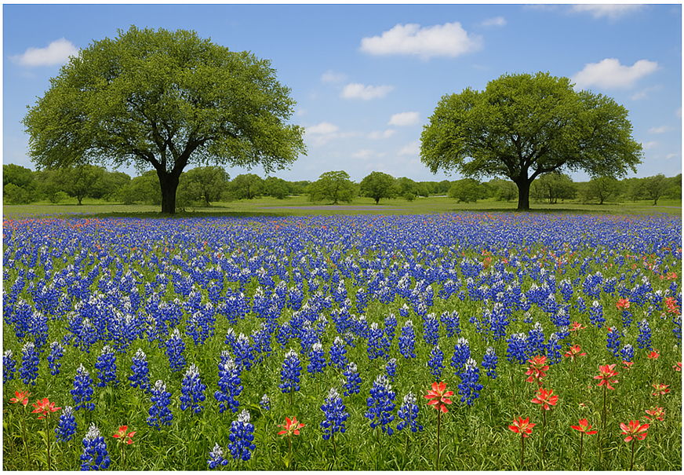
Note. A spring time, bluebonnets in bloom view of Texas. (A sentence or two describing the figure or relevant contextual information about it.)

Within the word document, you’ll want to Edit the Document Properties: Adding information to the document properties of your article helps identify your word document and add additional metadata. In Word, select “File” then “Properties.” Add the title of your article in the title field and your name in the author field.
New versions of Word offer an “Accessibility Checker” feature to easily check for accessibility issues in your document. In Word, select “Review” then “Check Accessibility.” The accessibility checker will appear and list any issues found in your document. Please address as many of these issues as possible. (See PKP’s guide on How to check an MS Word document for accessibility.)

Conclusion (Heading 1)
Thank you for reviewing this short paper template. The document takes influences from the iPres 2025 long paper format and the Journal of Open Educational Resources in Higher Education downloadable template. Best wishes with your own writing.

References (APA Style, Heading 1)
Buonarroti., Da Vinci, L., & Sanzio, R. (2026). Renaissance Painters. Journal of Art, 27(5), 80-87. https://doi,org/testdoi6787
Example, A. (2026). The references should use APA citation style. Journal Name, 26(4), 120-126. https://doi.org/testdoi6789
Journal of Open Educational Resources in Higher Education. (2026, March 8). Download the template for all article types here. Journal of Open Educational Resources in Higher Education. https://www.iastatedigitalpress.com/joerhe/site/sections/
iPres 2025 Wellington Aotearoa New Zealand. (2026, February 02) Submission Instructions - Full Paper Template. The 21st International Conference On Digital Preservation iPRES 2025. https://www.ipres2025.nz/submission-instructions
Lastname, F. M., & Lastname, F. M. (Year). Title of article. Title of Periodical, Vol.(Issue), page numbers. DOI
Lastname, F. M. (Year). Title of book. Publisher. URL
Lastname, F. M. (Year). Title of book [eBook edition]. Publisher. URL
Lastname, F. M. (Year). Title of book (N. Narrator, Narr.) [Audiobook]. Publisher. URL (if applicable)
Title of article. (Year, Month Date). In Wikipedia. URL of archived version of page

Appendix A. Appendix Title (Heading 2)

Appendix B. Appendix Title (Heading 2)

